

**HANGMAN GAME**

**Submitted By:**

**Asad Mehmood , 2020-CS-10**

**Submitted To:**

**Ms. Maida Shahid**

**For Fulfillment of Mid Term Project**

**CS 161 Programming Fundamentals**

**Department of Computer Science**

**University of Engineering and Technology, Lahore**

**Abstract:**

**HANGMAN** is a paper and pencil guessing game for two or more players. One player thinks of a word, phrase or sentence and the other(s) tries to guess it by suggesting letters within a certain number of guesses.

**Wireframes:**

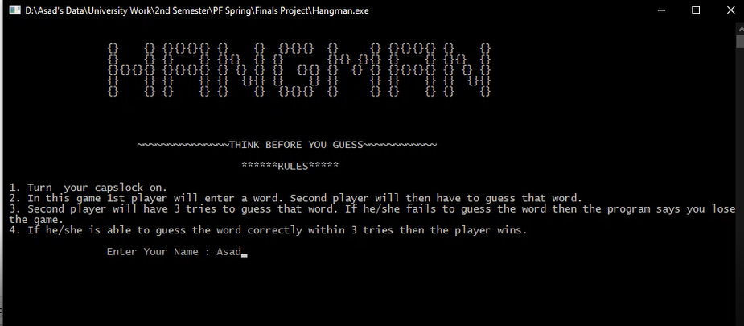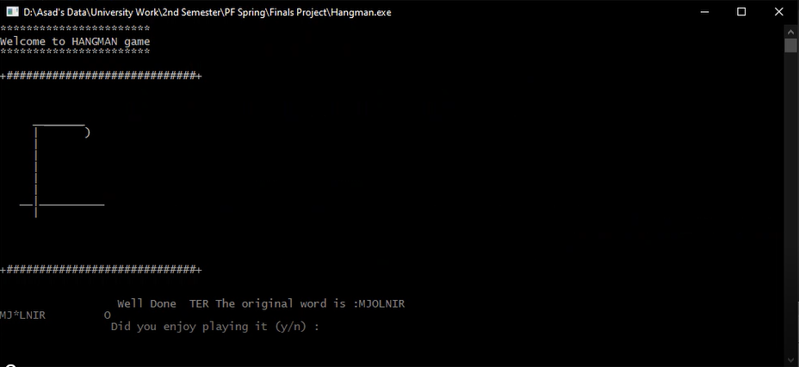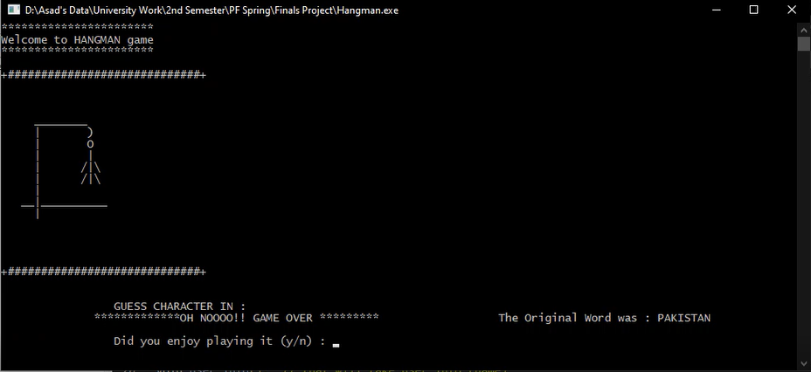

**Data Structure:**

Globally declared variables and arrays:

**Variables:**

string guess_word;

string original_word;

string user;

int I;

int j;

int wrong;

int p = 0;

int score = 0;

int a;

int b;

char c , x , X;

**2D Arrays:**

string map[18][32];

string words[4][4];

**Functions:**

void header();

void rules();

void showmap();

void hangman();

void user_info();

void random_word();

void guess();

char check_answer();

void print_score();

void gotoxy(short a, short b);

**Function Header and Description:**

* void header();

This will display welcome header

* void rules();

That function is to display game rules

* void showmap();

That will display hang map

* void hangman();

That will display hangman

* void user_info();

That will take user info (name)

* void random_word();

That will generate random word which is to guess

* void guess();

That will check if user is guessing correct word or not

* char check_answer();

That will check if word is correct or not.

* void print_score();

That will print total score

* void gotoxy(short a, short b);

**Code:**

#include <iostream>

#include <stdlib.h>

#include <stdio.h>

#include <conio.h>

#include <ctime>

#include <string>

#include <windows.h>

using namespace std;

//Variables

string guess_word , original_word , user;

int i , j , wrong , p = 0 , score = 0;

char c , x , X;

int a , b;

//Functions

void header(); // that will display welcome header

void rules(); // that function is to display game rules

void showmap(); // that will display hang map

void hangman(); // that will display hangman

void user_info(); // that will take user info (name)

void random_word(); // that will generate random word which is to guess

void guess(); // that will check if user is guessing correct word or not

char check_answer(); // that will check if word is correct or not.

void print_score(); // that will print total score

void gotoxy(short a, short b);

//2d Array

char map[18][32] = {

"+#############################+",

" ",

" ",

" ",

" ________ ",

" | ) ",

" | ",

" | ",

" | ",

" | ",

" | ",

" __|__________ ",

" | ",

" ",

" ",

" ",

" ",

"+#############################+"};

string words[4][4] = {{"PAKISTAN", "SHIELD", "MJOLNIR", "WORTHY"},

{"BLUSHING", "DYNAMIC", "DELIGHT", "STRAWBERRY"},

{"THOR", "SPARKLE", "DARK", "CAPTAIN"},

{"GROOT", "ROGERS", "WATCH", "SENORITTA"}};

int main()

{

system("cls");

rules();

user_info();

system("cls");

header();

showmap();

wrong = 0;

random_word();

while (guess_word.compare(original_word) != 0 && wrong < 5)

{

guess();

}

check_answer();

print_score();

}

void header() // that will display welcome header

{

cout << "***********************" << endl;

cout << "Welcome to HANGMAN game" << endl;

cout << "***********************" << endl;

cout << endl;

}

void showmap() // that will display hanging map

{

for (int i = 0; i < 18; i++)

{

for (int j = 0; j < 32; j++)

{

cout << map[i][j];

}

cout << endl;

}

}

void user_info() // that will take user info

{

cout << "\n\n\t\t Enter Your Name : ";

cin>>user;

cout << "\n\n\t\t HELLO " << user << "\n\n\n\t\t *** PLEASE TURN ON CAPSLOCK *** " << endl;

}

void rules()

{

cout << endl;

cout << endl;

cout << " {} {} {}{}{}{} {} {} {}{}{} {} {} {}{}{}{} {} {} " << endl;

cout << " {} {} {} {} {}{} {} {} {}{} {}{} {} {} {}{} {} " << endl;

cout << " {}{}{}{} {}{}{}{} {} {} {} {} {}{} {} {} {} {}{}{}{} {} {} {} " << endl;

cout << " {} {} {} {} {} {}{} {} {} {} {} {} {} {} {}{} " << endl;

cout << " {} {} {} {} {} {} {}{}{} {} {} {} {} {} {} " << endl;

cout << endl;

cout << endl;

cout << endl;

cout << endl;

cout << " ~~~~~~~~~~~~~~~THINK BEFORE YOU GUESS~~~~~~~~~~~~" << endl;

cout << endl;

cout << " ******RULES*****" << endl;

cout << endl;

cout<<" 1. Turn your capslock on. " << endl;

cout<<" 2. In this game 1st player will enter a word. Second player will then have to guess that word."<<endl;

cout<<" 3. Second player will have 3 tries to guess that word. If he/she fails to guess the word then the program says you lose the game."<<endl;

cout<<" 4. If he/she is able to guess the word correctly within 3 tries then the player wins.";

}

void random_word() // this function will use for generating random word

{

srand(time(0));

original_word = words[rand() % 4][rand() % 4];

guess_word = original_word;

for (int i = 0; i < guess_word.length(); i++)

guess_word[rand() % ((guess_word.length()) / 2)] = '*';

}

void guess()

{

cout << "\n\n\t\t GUESS CHARACTER IN : " << endl;

for (int j = 0; j < guess_word.length(); j++)

{

cout << guess_word[j];

}

cout << " \t";

cin >> c;

for (int j = 0; j < guess_word.length(); j++)

{

if (original_word[j] == c)

{

gotoxy(5, 22);

p++;

if (guess_word[j] == c)

{

cout<<" ";

gotoxy(5, 22);

break;

}

else

{

guess_word[j] = c;

}

}

}

if (p == 0)

{

wrong++;

hangman();

gotoxy(5, 22);

}

p = 0;

}

char check_answer()

{

if (guess_word.compare(original_word) == 0)

{

score = score + 10;

cout << "\n\n\t\t Well Done \t The original word is :";

for (i = 0; i < guess_word.length(); i++)

{

cout << original_word[i];

}

cout << " \n\n\t\t Did you enjoy playing it (y/n) : ";

cin >> x;

X = ((x == 'y' || x == 'Y' || x == 'n' || x == 'N'));

}

else

{

cout << "\n\n\n";

cout << " *************OH NOOOO!! GAME OVER ********* ";

cout << " The Original Word was : ";

for (i = 0; i < guess_word.length(); i++)

cout << original_word[i];

cout << " \n\n\t\t Did you enjoy playing it (y/n) : ";

cin >> x;

X = ((x == 'y' || x == 'Y' || x == 'n' || x == 'N'));

}

return X;

}

void print_score()

{

system("cls");

cout << endl;

cout << endl;

cout << " Thanks for playing " << user << ". Your final score is " << score << ".";

}

void hangman()

{

if (wrong == 1)

{

gotoxy(13, 10);

cout << "O";

}

if (wrong == 2)

{

gotoxy(13, 11);

cout << "|";

}

if (wrong == 3)

{

gotoxy(12, 12);

cout << "/|\\";

}

if (wrong == 4)

{

gotoxy(12, 13);

cout << "/|\\";

}

}

void gotoxy(short a, short b)

{

HANDLE hStdout = GetStdHandle(STD_OUTPUT_HANDLE);

COORD position = {a, b};

SetConsoleCursorPosition(hStdout, position);

}